Website Script

HOME PAGE

### Hero

We build flexible, AI-and-agent-first platforms (on-premise or your cloud) that help you become DPDP-compliant and audit-ready, without the usual headache. Built for a digital-first India, priced to actually make sense.

`[Primary CTA: Book a Demo]` `[Secondary CTA: See Our Offerings]`

Your Data. Your Infrastructure. Your Control.

We know handing over your data feels risky, so we don't ask you to. Everything stays inside your own environment and under your control. **0 bytes leave your network**

#Our Approach

Compliance doesn't happen overnight, and we don't pretend it does. We built our platforms around how the journey actually unfolds.

![Ascending journey map: Learn, then Assess, then Operationalize, each step higher than the last]
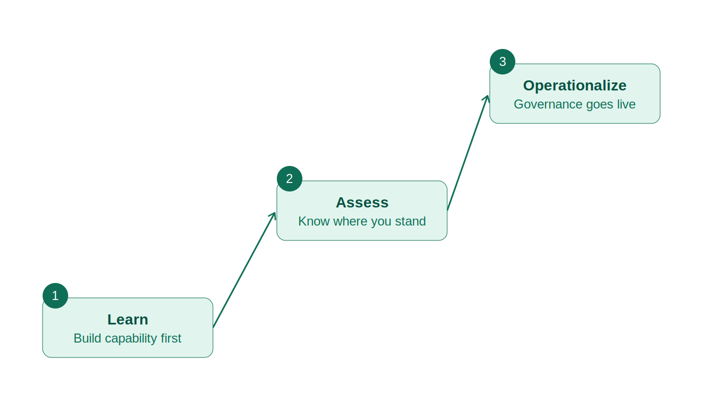

1. **Learn** — build capability first, so your team actually understands what they're doing
2. **Assess** — know where you really stand, with our assessment tools
3. **Operationalize** — governance goes live, with software that fits how you work

*One journey. Multiple platforms. Zero guesswork.*

#OUR PLATFORMS

#NiyamSaathi: Assessment Tool

*Know where you stand, and what to tackle first.*

- **A control library that's actually yours** — start with our master controls or build your own around your organization
- **Onboarding that doesn't feel like homework** — a simple, structured process to bring your assets in
- **Readiness assessments, start to finish for DPDP Act, CERT IN Guidelines, RBI Governance, IT ACT, ** — run them right from your portal
- **Keep everyone accountable** — assign tasks across teams and officers
- **Everyone gets their own space** — role-specific dashboards so people see what matters to them
- **Risk analytics you can act on** — real scores, real insights, not just numbers
- **Run a compliance & security scan** whenever you need one
- **A built-in learning library (LMS)** — train your team without switching tools
- in built chatbot for questions that may arise when using the tool
- 🔲 *Automatic gap-spotting and suggestions (coming soon)*

# E-Sehmati: Consent Management & Governance Software

*One place for everything consent*

- **Handle the whole consent lifecycle** — collect it, update it, let people withdraw or renew it, all from one portal
- **Find your data without the headache** — we help identify and classify personal data across your org
- **See where your data actually goes** — visual maps showing how it's collected, processed, stored, and shared
- **Manage consent in real time**, using those same maps
- **Bring old consent up to date** — run campaigns to refresh or re-confirm it
- **Consent banners that fit anywhere** — customizable, consistent, and available in 22 languages
- **Handle requests and grievances properly** — structured workflows so nothing falls through the cracks
- **Set access up your way** — flexible roles and permissions
- **Keep a clean, audit-ready trail** — every action logged, ready for review
- **Never miss a breach notification** — automated workflows keep reporting on time

---

### Platform 3: DPDPQuest (should be mentioned first)

*Finally, a way to actually understand the DPDP Act.*

- **A free, adaptive learning app** — because dense legal text shouldn't be the only way to learn this
- **Learning that doesn't feel like a lecture** — videos, an AI chatbot, flashcards, quizzes, and games
- **Track real progress**, not just who clicked "complete"
- **Everyone learns what matters to them** — content tailored to each role
- **A full library at your fingertips** — books and resources, all in one spot
- can be used online

---

### 🔲 Product 4: TPRM (will add name)

**Manage vendors without the chaos** — invitations, contracts, and compliance tracking, together
- Manage Agreements (formation and cancellation)
- Suppression of data
- Manage ROPA

### 🔲 Product 5: Cyber Insurance

Stay one step ahead and protect yourself against potential vendor risks and breaches, resulting in penalties for your organisation. At Tango, we have partnered with a trusted cyber insurance firm, saving you from massive fines.

### 🔲 Service 1: DPO as a service (will add name)

According to DPDP rules, all significant data fiduciaries are mandated to have a DPO (Data Protection Officer). DPO as a service is for those organizations that hold valuable data but are small and cannot afford to have a in house DPO. For those organisations, our portal helps you connect with certified DPOs and outsource this role.

### Service 2: VAPT Testing

--- Covers four critical attack surfaces: external penetration testing, internal penetration testing, web application testing, and AI/ML security testing

Methodology grounded in globally recognised standards: OWASP, PTES, OSSTMM, NIST SP 800-115, and purpose-built AI/ML security frameworks

Includes four deliverables: an executive summary report, a technical deep-dive report, a vulnerability evidence package, and a complimentary retest report

Six weeks of active testing plus a retest once you are ready; conducted fully remotely unless onsite access is requested for internal testing

## HOW IT WORKS

**Three simple phases.**

1. **Understand & Assess** — we start by figuring out where you stand
2. **Install** — we set up the tools that fit your world
3. **Implement** — governance goes live, and we stick around to help

--- as a timeline

## Constant Innovation

We're already using AI to take the manual, repetitive parts of compliance off your team's plate. And we're just getting started.

Regulations change, threats change, technology changes, and honestly, so do we. Every new version we ship brings smarter AI and better tools, so staying compliant gets easier over time, not harder. You'll never have to start from scratch.

*— Aashray Infotech Private Limited*

## Trusted By The Best

* client names go here.*

---

## ABOUT US PAGE

**We're on a mission to make compliance less painful.**

We're Aashray Infotech, an Indian tech startup that believes compliance shouldn't feel like a burden. We blend AI and agentic technology with real, deep knowledge of the DPDP Act to help organizations get compliant and stay that way, all without handing over control of their data or slowing down their business.

Leadership Team

